Inputs

1. Type
   1. zoos/theme parks: self explanatory
   2. Areas: large areas of land and/or a community
   3. Landmark: singular landmark (both natural and manmade).
   4. Restaurant: a restaurant
   5. Museum: a singular building that showcases one topic extensively ( museums).
2. Regions
   1. 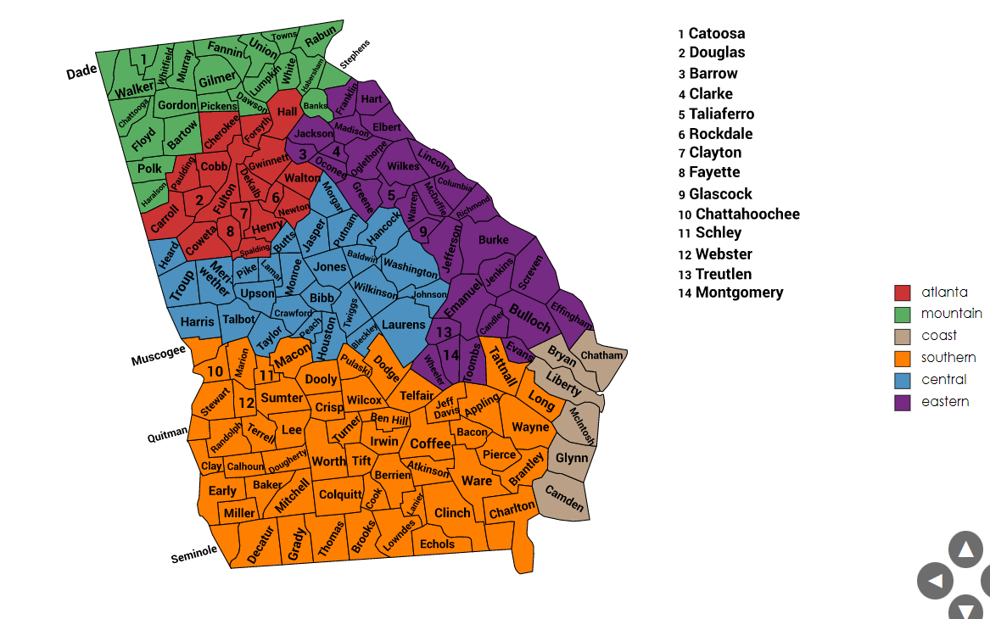
3. outdoor/indoor
   1. Rural: no major city nearby[no rural choice in atlanta]
   2. Suburban: major city nearby
   3. Urban: inside a major city
4. Ratings (from google maps 5-star system)

Libraries used:

-openpyxl: no download needed, used to get data from excel file

-kivy: used to build gui

-webbrowser: used to access the web when dealing with websites

Library Documentation:

Kivy:

Kivy app: <https://kivy.org/doc/stable/api-kivy.app.html>

Kivy Label : <https://kivy.org/doc/stable/api-kivy.uix.label.html>

Kivy Button : <https://kivy.org/doc/stable/api-kivy.uix.button.html>

Kivy Widget: <https://kivy.org/doc/stable/api-kivy.uix.widget.html>

Kivy Slider: <https://kivy.org/doc/stable/api-kivy.uix.slider.html>

Kivy ScreenManager: <https://kivy.org/doc/stable/api-kivy.uix.screenmanager.html>

Kivy Builder: <https://kivy.org/doc/stable/api-kivy.lang.builder.html>

Kivy Window: <https://kivy.org/doc/stable/api-kivy.core.window.html>

Kivy Numeric Property: [https://kivy.org/doc/stable/api-kivy.properties.html](https://kivy.org/doc/stable/api-kivy.properties.html#kivy.properties)

- click on numericProperty hyperlink.

Openpyxl: <https://openpyxl.readthedocs.io/en/stable/>

Functions I’ve used:

Load workBook =Simple usage 🡪 Read an existing workbook

Looping and using data = Tutorial 🡪Playing with Data

Webbrowser: <https://docs.python.org/3/library/webbrowser.html>

Open Website: Scroll down – 1st page – (open)